Django for web development

(Note: this is for windows OS)

1. Create a virtual environment for your Django project.

On the command prompt or the terminal navigate to your project folder and write the following command: “*python -m venv <name>*”. give a name to your virtual environment.

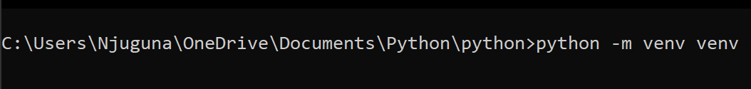

1. Activate the virtual environment.

Make sure on the terminal you are on the same directory as the virtual environment. For example let us say my virtual environment is called “venv” this is the command to activate: “*venv\Scripts\activate*”.

Before activating:

After activating:

1. Install Django.

The command is: “*pip install django*”



1. Check if django has been installed correctly

The command is: “*pip freeze*”

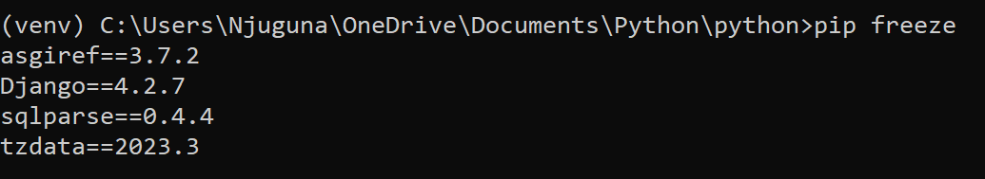

NOTE: When Django is installed other libraries that are used within the library are also installed.

1. Create a Django project

The command is: “*django-admin startproject <name>*”



1. Change directory to saturdayproject

The command is: “*cd saturdayproject*”

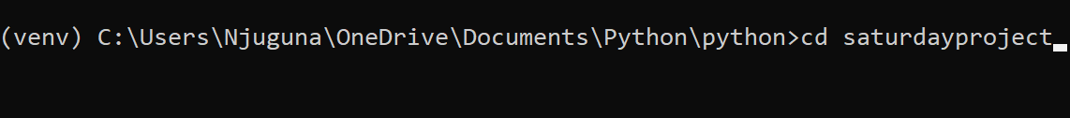

1. Check if Django project has been created successfully.

First check you are in the same directory as manage.py. Command is “*dir*” or “*ls*” in powershell.

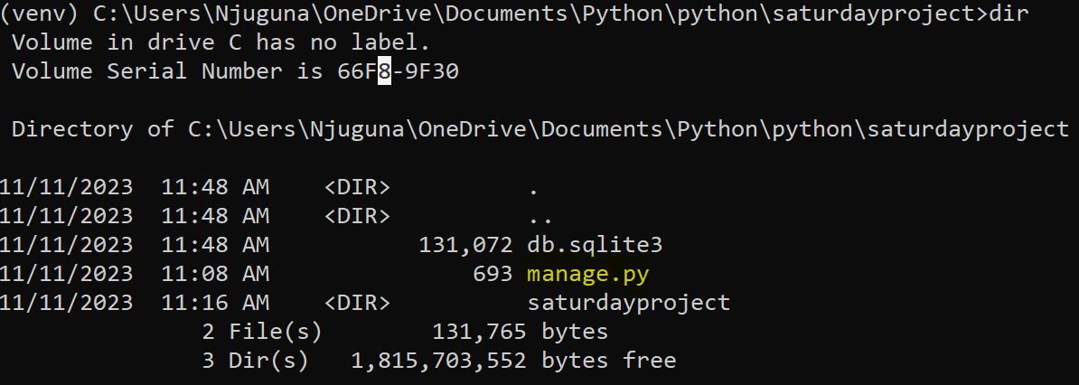

To start the development server the command is: “*python manage.py runserver*”

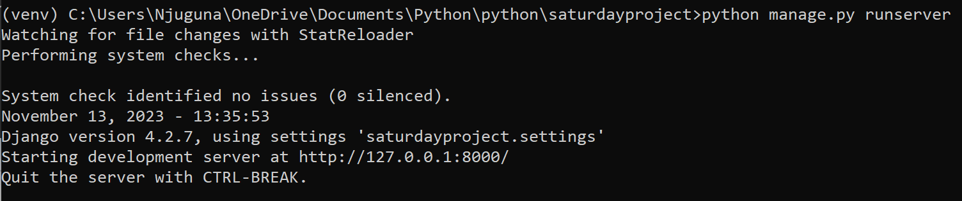

Go to <http://127.0.0.1:8000/> on a web browser. This is the page it should show: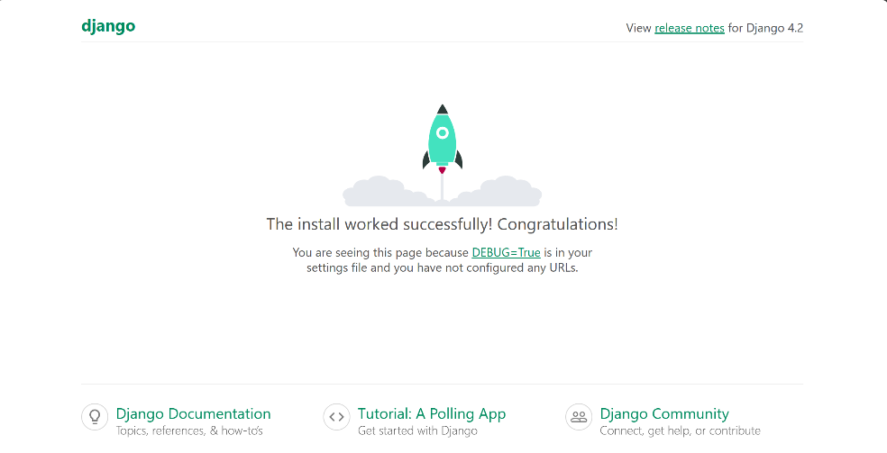

1. Creating the database.

First terminate the development server.

Write the following commands:

* “*python manage.py makemigrations*”
* “*python manage.py migrate*”

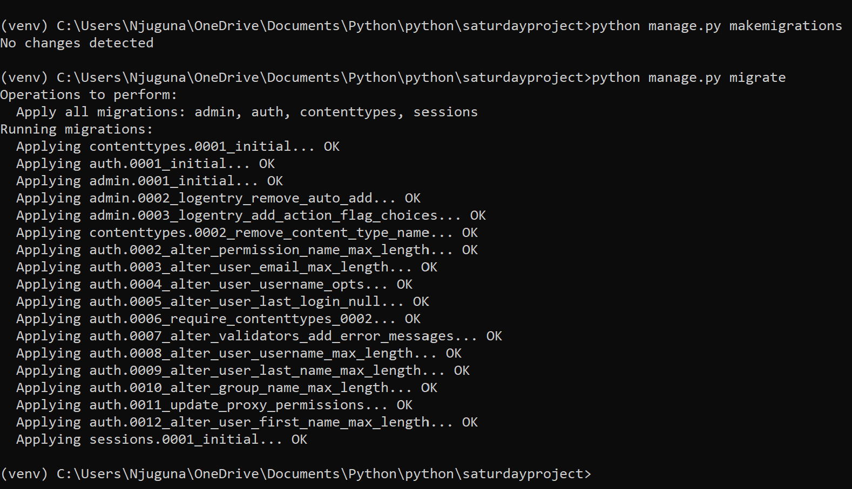

Django has predefined tables and attributes. The most important table is the User.

1. Accessing the admin panel

Django has an admin panel where only users who have designated as staff can have access to.

The admin panel does not have a signup page so we have to create a user on the command line. The command is: “*python manage.py createsuperuser*”

Start the development server and go to: <http://127.0.0.1:8000/admin> use your credentials to login.

